Ministerul Educației și Cercetării al Republicii Moldova

Universitatea Tehnică a Moldovei

Facultatea Calculatoare, Informatică și Microelectronică

Departamentul Ingineria Software și Automatică

**RAPORT**

**Lucrarea de laborator nr.3**

**La Ciruite și Dispozitive Electrice**

*Tema: Studierea caracteristicelor și a parametrilor diodelor semiconductoare*

A efectuat: st.gr. TI-211 Șlicari Eugeniu

A verificat: Lupan Cristian

Chișinău 2022

**1. Scopul lucrării:** de a lua cunoștință cu principiile de funcționare, caracteristicele și parametrii

diodelor redresoare, diodelor Zener și a diodelor luminiscente (LED). A

scoate datele și a construi caracteristicile voltmetrice. A determina parametrii

fundamentali ai dispozitivelor respective.

**2. Schemele circuitelor electrice:**

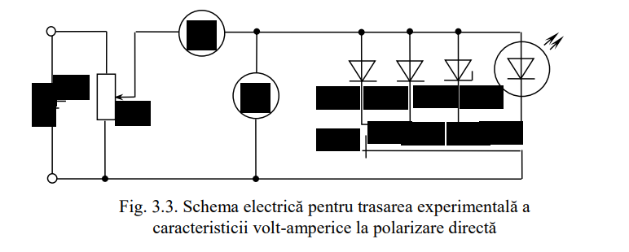

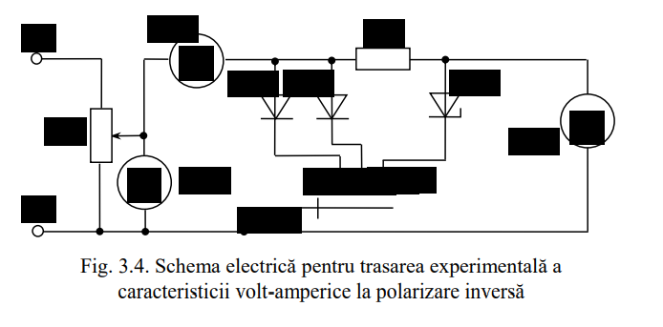

**Tabelul 3.1**

|  |  |  |  |  |  |  |  |  |  |  |
| --- | --- | --- | --- | --- | --- | --- | --- | --- | --- | --- |
| **Udir, V** | | **0** | **0.05** | **0.1** | **0.15** | **0.2** | **0.25** | **0.3** | **0.35** | **0.4** |
| **Idir, mA** | **D1** | **0** | **0,0035** | **0,0218** | **0,134** | **0,9** | **4,2** | **13,8** | **61,8** | **131,2** |

**Tabelul 3.2**

|  |  |  |  |  |  |  |  |  |  |  |  |
| --- | --- | --- | --- | --- | --- | --- | --- | --- | --- | --- | --- |
| **Udir, V** | | **0** | **0.1** | **0.3** | **0.5** | **0.6** | **0.65** | **0.7** | **0.75** | **0.8** | **0.85** |
| **Idir, mA** | **D2** | **0** | **0,0001** | **0,0018** | **0,067** | **0,5** | **1,8** | **2,9** | **6,4** | **13,4** | **16,4** |
| **D3** | **0** | **0** | **0** | **0,002** | **0,01** | **0,049** | **0,6** | **3,5** | **12,5** | **56,8** |

**Tabelul 3.3**

|  |  |  |  |  |  |  |  |  |  |  |  |  |  |  |
| --- | --- | --- | --- | --- | --- | --- | --- | --- | --- | --- | --- | --- | --- | --- |
| **Udir, V** | | **0** | **0.5** | **1** | **1.1** | **1.2** | **1.3** | **1.4** | **1.5** | **1.6** | **1.7** | **1.8** | **1.9** | **2** |
| **Idir, mA** | **D4** | **0** | **0** | **0** | **0** | **0,0001** | **0,0001** | **0,0002** | **0,0021** | **0,0077** | **0,138** | **1,1** | **4** | **9,7** |

**Tabelul 3.4**

|  |  |  |  |  |  |  |  |  |  |  |  |
| --- | --- | --- | --- | --- | --- | --- | --- | --- | --- | --- | --- |
| **Uinv, V** | | **0** | **1** | **3** | **5** | **10** | **11** | **12** | **13** | **14** | **15** |
| **Iinv, mA** | **D1** | **0** | **0,0012** | **0,0016** | **0,002** | **0,0028** | **0,0029** | **0,0031** | **0,0032** | **0,0034** | **0,0036** |
| **D2** | **0** | **0** | **0,0002** | **0,0004** | **0,0009** | **0,001** | **0,0011** | **0,0012** | **0,0013** | **0,0014** |

**Tabelul 3.5**

|  |  |  |  |  |  |  |  |  |  |  |  |  |
| --- | --- | --- | --- | --- | --- | --- | --- | --- | --- | --- | --- | --- |
| **Ip3, mA** | **0** | **0,0004** | **0,0007** | **1** | **2** | **5** | **10** | **15** | **20** | **25** | **30** | **35** |
| **UD3, V** | **-0** | **-5** | **-7** | **-7,4** | **-7,56** | **-7,6** | **-7,66** | **-7,72** | **-7,78** | **-7,86** | **-7,93** | **-7,98** |

**6. Concluzii:**

In urma efectuarii lucrarii de laborator am facut cunostinta cu principiile de functionare, caracteristicile si parametrii diodelor redresoare, diodei Zener si ale diodelor luminescente. Avand schema electrica de pe macheta si cu ajutorul multimetrului am ridicat ramura de polenizare si am construit graficele afland tensiunea de prag a diodelor date.